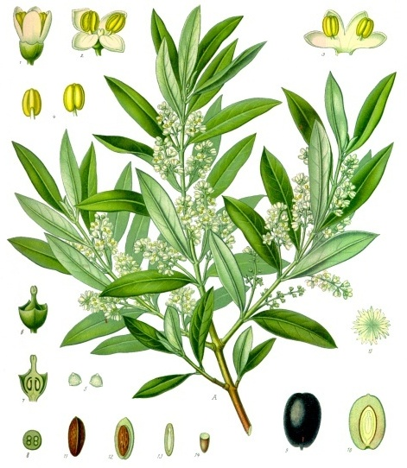
FLORIDA OLIVE COUNCIL, LAA
3324 W. UNIVERSITY AVE. #160 GAINESVILLE, FL 32607

Contact: Michael O’Hara Garcia (202) 246-2001
michael@floridaolivecouncil.org

INVOICE
Date: 28 April 2015

TO: Dr. Wes Wood
UF/IFAS WFREC
5988 Highway 90 Building 4900
Milton, Florida 32583

Reference: DONATION - FOC/IFAS Olive Rch Plot

Qty | Code | Description | Price | Amount
6 | 1 gal | Koroneiki | 15.50 | 93.00
10 | 1 gal | Arbequina | 15.50 | 155.00
4 | 1 gal | Chitoni | 15.50 | 62.00
4 | 4" | Frantoio | 10.50 | 42.00
4 | 4" | Empeltre | 10.50 | 42.00
4 | 4" | Grignan | 10.50 | 42.00
4 | 4" | Taggiasca | 10.50 | 42.00
4 | 1 gal | Hojiblanca | 15.50 | 62.00
4 | 1 gal | Ascolana | 15.50 | 62.00
4 | 1 gal | Sikitita | 15.50 | 62.00
45 |  | SubTotal |  | $664.00
 |  | TOTAL DUE |  | 000.00

MAKE CHECKS PAYABLE TO: Florida Olive Council, LAA

Received above referenced nursery stock in good condition.

__________________________________________________________________

